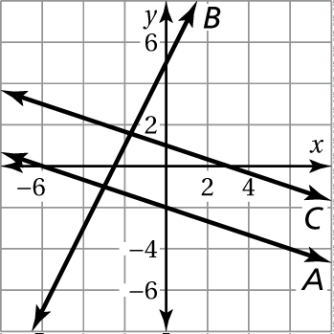Name Date

Homework

4.2

1. Refer to the graph.

a. Which lines have negative slopes?

b. Which line has the steepest slope?

c. Are any two of the lines parallel? How do you know?

Draw a line through each point using the given slope. What do you notice about the two lines?

2.  3. 

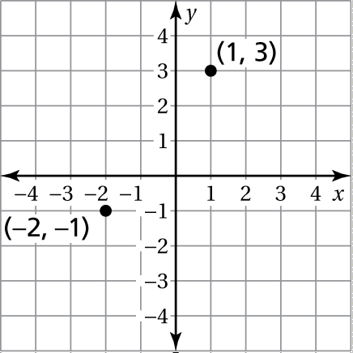 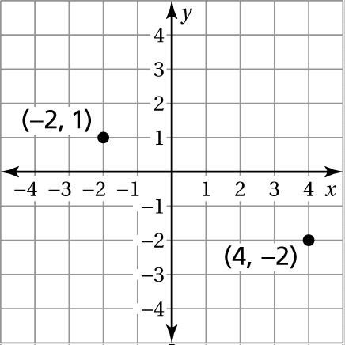

Find the slope of the line. Then reduce it completely.

4. 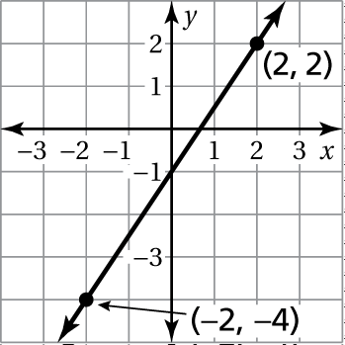 5. 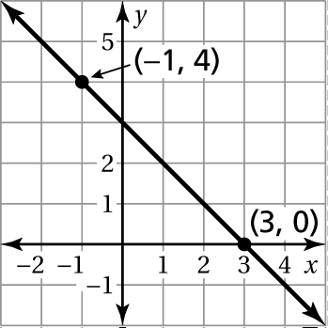

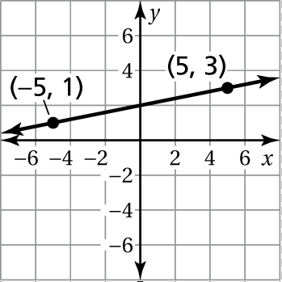 6. 7. 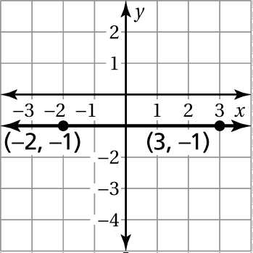

Find the slope of the line through the given points.

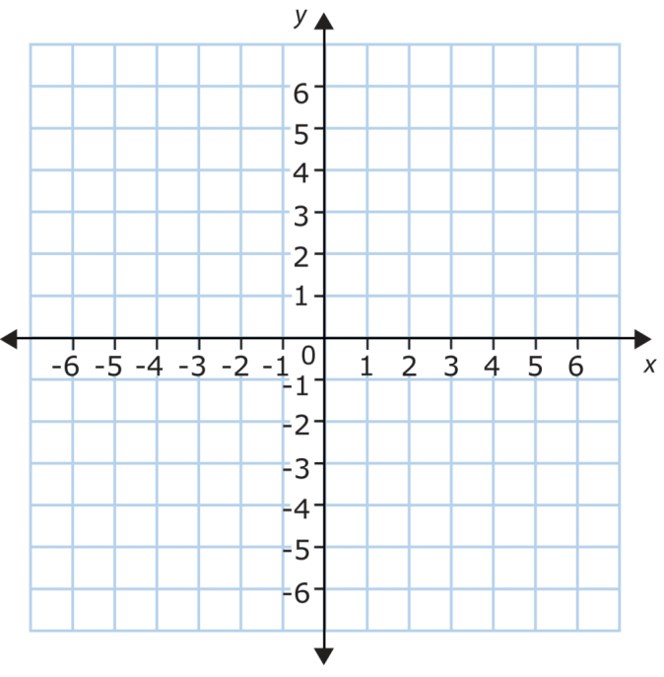 8.  9. 

10.  11. 

12. An awning covers a window that is 4 feet high. When the awning is opened, it extends 2 feet from the base of the window. Find the slope of the awning by drawing a picture.

**13**. A ramp used to remove furniture from a moving truck has a slope of The height of the ramp is 4 feet. How far does the base of the ramp extend from the end of the truck?



The points in the table lie on a line. Draw it and Find the slope of the line.

14.

|  |  |  |  |  |
| --- | --- | --- | --- | --- |
| ***x*** | 0 | 2 | 4 | 6 |
| ***y*** | −4 | −1 | 2 | 5 |